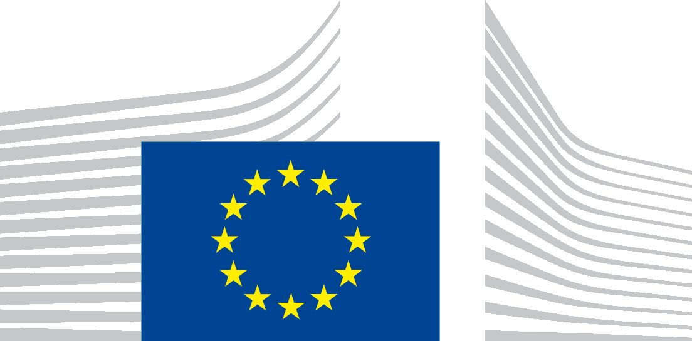 | Education, Audiovisual and Culture Executive Agency  Erasmus+: Higher Education - Knowledge Alliances, Bologna Support, Jean Monnet

Institutional Profile - Change of name of the institution
In case of a change to the name of an ECHE holder please complete the boxes below and send the update to the Executive Agency EACEA by e-mail to: EACEA-ECHE@ec.europa.eu as well as a copy to your national agency: erasmus@oph.fi
The change of name has to be updated in the Participant Portal: http://ec.europa.eu/education/participants/portal/desktop/en/home.html

A. Name of the institution:

B. Erasmus ID code: (e.g. F PARIS34)

C. PIC code

D. New Name
Full legal name of the institution in the national language
Translation in English
Website
Official date of change
E. Old Name
Full legal name of the institution in the national language
Translation in English

